# STRUCTED QUERY LANGUAGE(SQL)

**What is SQL?**

* SQL stands for Structured Query Language
* SQL lets you access and manipulate databases
* SQL became a standard of the American National Standards Institute (ANSI) in 1986, and of the International Organization for Standardization (ISO) in 1987

SQL Commands:

There are five types of SQL commands: DDL, DML, DCL, TCL, and DQL.

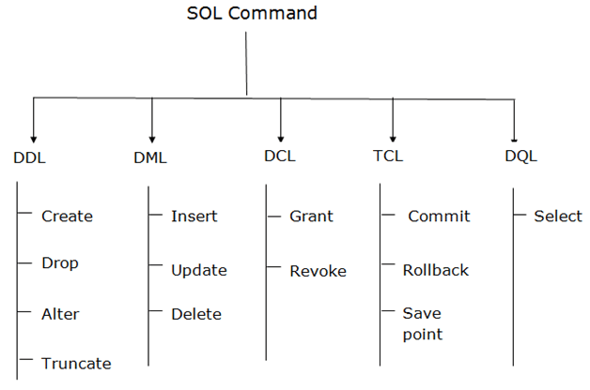

Some of The Most Important SQL Commands

* Select - extracts data from a database
* Update - updates data in a database
* Delete - deletes data from a database
* Insert Into - inserts new data into a database
* Create Database - creates a new database
* Alter Database - modifies a database
* Create table - creates a new table
* Alter table - modifies a table
* Drop table - deletes a table
* Create Index - creates an index (search key)
* Drop Index - deletes an index

Creating table:

mysql> create database;

This is first step to create database.

mysql> show databases;

Second step to show our database

mysql> use datacase;

mysql> create table stud(id int, name varchar(10), age int);

Insert values:

mysql> insert into stud vaues(100,’gayu’,22);

mysql> insert into stud vaues(101,’adhi’,20);

mysql> insert into stud vaues(102,’anu’,24);

select table:

mysql> select* from stud;

id name age

100 gayu 22

101 adhi 20

102 anu 24

Alter table:

cc alter table stud add(address varchar(20) );

mysql> select* from stud;

id name age address

100 gayu 22 null

101 adhi 20 null

102 anu 24 null

Drop table:

DROP TABLE stud;

stud: Name of the table to be deleted.

mysql>Alter TABLE stud DROP address;

id name age

100 gayu 22

101 adhi 20

102 anu 24

Truncate table:

TRUNCATE TABLE stud;

stud: Name of the table to be truncated.

Rename table:

mysql> alter table table_name rename to new_table_name;

Update table:

mysql>UPDATE table_name SET name=renu, age=20 WHERE id=102;

id name age

100 gayu 22

101 adhi 20

102 renu 20

COMMIT– commits a Transaction.

COMMIT;

ROLLBACK– rollbacks a transaction in case of any error occurs.

This command restores the database to last commited state.

ROLLBACK TO savepoint_name;

SAVEPOINT–sets a savepoint within a transaction.

SAVEPOINT savepoint_name;

id name age

100 gayu 22

101 adhi 20

102 renu 20

103 anu 25

mysql>rollback A;

id name age

100 gayu 22

101 adhi 20

102 renu 20

Boolean exp:

id name age salary

100 gayu 22 40000

101 adhi 20 50000

102 renu 20 45000

103 anu 25 55000

mysql > select * from stud WHERE salary>45000;

id name age salary

101 adhi 20 50000

103 anu 25 55000

Orderby:

mysql>select*from stud orderby name;

id name age salary

100 adhi 22 40000

101 anu 20 50000

102 gayu 20 45000

103 renu 25 55000